BFOR 516 – Group Project Milestone 2: Progress Report
Title: Predicting Credit Card Defaults using Machine Learning Techniques
Team Members: Spencer Kone, Muhammad H Bahar, Kunapureddy Leela Pavan Kumar, Maddirala, Shalem Raju.

Date: March 2026

1. Detailed Description
1a. Project Objective (and any evolution from Milestone 1)
This task is same as that of Milestone 1. Using the Decision Tree Classifier (DT) algorithm, we are required to train the model that can predict the probability of default or non-payment by the Taiwan credit card clients next month. Out of the three models compared in this task, we chose to implement the Decision Tree Classifier. Upon examining the feature importance of the Decision Tree Classifier, we found that it uses Gini impurity to calculate the feature importance which is not available for the Logistic Regression and the Gaussian Naive Bayes algorithms in the same way. The understanding of the dimensionality of the data and the relationships within the features is also required for modeling. Therefore, we used the Principal Component Analysis (PCA) to achieve the same.

1b. Dataset Description
Dataset: Default of Credit Card Clients Source: UCI Machine Learning Repository — https://archive.ics.uci.edu/dataset/350/default+of+credit+card+clients Original Paper: Yeh, I. C., & Lien, C. H. (2009). The comparisons of data mining techniques for the predictive accuracy of probability of default of credit card clients. Expert Systems with Applications, 36(2), 2473–2480.

Confirmed Dataset Facts (from notebook output):

Shape: 30,000 rows × 24 columns (23 features + 1 target)
All columns: integer type (int64), no null values
Memory: 5.7 MB
Target distribution: 23,364 no default (77.88%) vs. 6,636 default (22.12%)
Class imbalance ratio: 3.5:1 (no default : default)
Credit limit range: NT$10,000 – NT$1,000,000 (mean: NT$167,484)
Age range: 21–79 years (mean: 35.49)

1c. Model Selection Rationale
Model 1: Logistic Regression

We selected Logistic Regression for credit default prediction primarily due to its industry standard status and interpretability. The logistic coefficients directly show the impact of each feature on the probability of default – a critical aspect for understanding risk. While LR is a well-established approach, its assumption of a linear decision boundary presents a limitation when dealing with complex, non-linear relationships within the credit card data. The PCA scatter plot confirms this – the data exhibits limited linear separability. The class imbalance issue was addressed by employing class_weight='balanced' during training, which automatically adjusts sample weights inversely proportional to class frequency, mitigating the bias inherent in traditional algorithms.

Model 2: Gaussian Naive Bayes

We have chosen to use the Gaussian Naive Bayes (GNB) algorithm for this benchmark. As mentioned before, logistic regression is a deterministic algorithm, which means that it models the relationship between features and target using a linear equation. On the other hand, Naive Bayes is a probabilistic algorithm which uses Bayes’ theorem to compute the probability of features given the target. The assumption made by the Naive Bayes algorithm is that all the features are independent given the target. It is quite obvious from the correlation matrix of PAY_AMT1 – PAY_AMT6 that the assumption of feature independence is not satisfied. The correlation coefficients are all above 0.9 and the coefficients of PAY_0 – PAY_6 are high and correlated with the target. So, the performance of the GNB is not good, and it is decreased when the class_weight parameter is not provided.

Model 3: Decision Tree Classifier

Since our features were not linearly separable with respect to the Logistic Regression model, we used Decision Tree Classifier instead. The decision tree is also shown below. Unlike Logistic Regression, Decision Trees do not need the features to be scaled. We used the Gini impurity for the Decision Tree Classifier. PAY_0 has the highest contribution to the classifier with a feature importance of 74.61% .

Comparison Strategy

The method used to model evaluation is that the performance of the proposed models were evaluated with various performance metrics. Since the loss for the bank is more sensitive to false negatives than false positives, recall is more important than precision. The precision is still important to the bank because of the false positives which means that true customers with good credit scores are being declined credit. The criterion which combines precision and recall at all possible operating points is the Receiver Operating Characteristic (ROC) Area Under the Curve (AUC). In the experimentation 5-fold Stratified Cross Validation (CV) was used in order to obtain a more realistic view of the model performance.

2. Dataset Preparation
2a. Initial Inspection
Confirmed facts (notebook output):

30,000 rows, 24 columns — all int64, no missing values
35 duplicate rows found (noted; not dropped — rows represent distinct clients who happen to share the same feature values)
Default rate: 22.12% (6,636 defaults out of 30,000)
Credit limit (LIMIT_BAL): right-skewed, mean NT$167,484, max NT$1,000,000
PAY status columns: values range from -2 to +8; mean near 0 (most clients pay on time)
BILL_AMT columns: mean ~NT$40k–51k with high standard deviation (some clients have very large balances including negatives, indicating credits/refunds)

After having a first look at the whole dataset we have noticed some interesting characteristics in the data. - The default rate is quite high and is 22.12%. - The Credit limit (LIMIT_BAL) is right skewed and there is a high variance of credit given to the customers. The minimum value of this feature is 10000 (1000 USD) and the maximum value is 1000000 (100000 USD). - The mean of the PAY status columns is centred close to zero and is located within the range of -2 to 8. This indicates that most customers pay their invoices on time. - The Bills (BILL_AMT) dataset contains some high and some low values. There are obviously large discrepancies between the charges on the bills for different customers. Some charges appear to be negative, which probably represents credits or refunds being applied to the customer’s account.

2b. Data Cleaning
Issue 1 — Invalid EDUCATION values:

The original dataset documentation (Yeh & Lien, 2009) defines only:

1 = graduate school, 2 = university, 3 = high school, 4 = others
Values 0, 5, 6 are present but undocumented.

Actual counts from notebook:

EDUCATION values before cleaning: [0, 1, 2, 3, 4, 5, 6]
345 rows contained undocumented values (0, 5, or 6)
Action: remapped all three to 4 (others)
EDUCATION values after cleaning: [1, 2, 3, 4]
Issue 2 — Invalid MARRIAGE values:

Documentation defines: 1 = married, 2 = single, 3 = others. Value 0 is undocumented.

MARRIAGE values before cleaning: [0, 1, 2, 3]
54 rows contained undocumented value 0
Action: remapped to 3 (others)
MARRIAGE values after cleaning: [1, 2, 3]
Total rows affected by cleaning: 399 rows out of 30,000 (1.3%)

# Fix undocumented EDUCATION values (0, 5, 6 → 4 = Other)
df['EDUCATION'] = df['EDUCATION'].replace({0: 4, 5: 4, 6: 4})
# Fix undocumented MARRIAGE values (0 → 3 = Other)
df['MARRIAGE'] = df['MARRIAGE'].replace({0: 3})

We discovered undocumented values in the ‘EDUCATION’ and ‘MARRIAGE’ columns by conducting an initial value_counts() analysis on these categorical features. The first value_counts() for categorical variables show a large number of undefined values in EDUCATION and MARRIAGE columns. According to the study of Yeh & Lien (2009), there are 4 categories of educational level and marital status. The undefined values coded as 0, 5 and 6 should represent the other categories and we replace them with category 4. The record loss for the variables is less than 1.3% and we assume that the missing values represent the category that the authors call “miscellaneous” without further explanation.

2c. Feature Engineering & Preprocessing
Pipeline summary (confirmed from notebook):

Step Detail Confirmed Output
Feature/target split X: 23 features, y: default X shape: (30000, 23)
Stratified train/test split 80/20, random_state=42 Train: 24,000 / Test: 6,000
Train default rate Preserved by stratification 22.12% (matches full dataset)
Test default rate Preserved by stratification 22.12% (matches full dataset)
Train StandardScaler Fit on train, transform both Train mean: 0.000000, std: 1.000000
Test StandardScaler transform only — no data leakage X_test_scaled = scaler.transform(X_test)
X_train, X_test, y_train, y_test = train_test_split(
X, y, test_size=0.2, random_state=42, stratify=y
)
scaler = StandardScaler()
X_train_scaled = scaler.fit_transform(X_train)
X_test_scaled = scaler.transform(X_test) # transform only — no data leakage

Since we have the dataset we need to prepare our data so that our predictive model will be able to learn as much as possible from it. So in this stage of the workflow we simply need to prepare our data in the best way possible that we can learn from it. In this stage we just make sure that we have enough and the right data to train a good model. The training and test set were already split using the stratified train-test split with ratio 80:20 and random_state = 42, stratify = y. This ensures that there is no bias in the default rate (22.12%) of the original dataset in the test set. The numerical variables in the dataset were scaled using the StandardScaler. In this case the StandardScaler was fitted to the training data (X_train). The training and test data (X_train_scaled and X_test_scaled) were then standardised to make sure that there was no leakage of information from the test set.

3. Model Building
3a. Logistic Regression
lr_model = LogisticRegression(
C=1.0, # L2 regularization strength (inverse); default = no extra penalty
max_iter=1000, # ensures solver convergence on 24k samples
class_weight='balanced', # compensates for 3.5:1 class imbalance
solver='lbfgs', # efficient for binary classification, supports L2
random_state=42
)

We implemented a Logistic Regression model with key hyperparameters tuned for this dataset. The C parameter (regularization strength) was set to 1.0, providing a moderate amount of regularization to prevent overfitting. max_iter was set to 1000, to ensure solver convergence, especially on the larger dataset. The class_weight='balanced' parameter was crucial to address the 3.5:1 class imbalance – it dynamically adjusts sample weights to give higher importance to the minority (default) class during training. The solver='lbfgs' algorithm offers an efficient solution for binary classification problems with L2 regularization support.

3b. Gaussian Naive Bayes
nb_model = GaussianNB()
# No hyperparameters set — GNB estimates Gaussian parameters (mean, var)
# per feature per class from training data automatically

The Gaussian Naive Bayes model assumes that each feature is normally distributed within each class. This means the model will estimate the mean and variance of each feature independently for each class based on the training data. The absence of hyperparameters simplifies the model; however, the crucial "naive" independence assumption poses a significant limitation – the strong correlations between features like PAY_AMT1–6 and the target variable are clearly violated. Because of this, GNB's performance likely suffers compared to more sophisticated models. The model doesn't explicitly handle the class imbalance, relying on the inherent class proportions in the training data.

3c. Decision Tree Classifier
dt_model = DecisionTreeClassifier(
max_depth=5, # limits tree depth to prevent overfitting
min_samples_split=50, # node must have ≥50 samples to split
min_samples_leaf=20, # leaf must have ≥20 samples (stable estimates)
class_weight='balanced',
criterion='gini', # Gini impurity for split quality
random_state=42
)
# Decision Tree is scale-invariant — uses raw (unscaled) X_train / X_test

We built a Decision Tree Classifier from scratch. It is very basic classifier, and we needed to take care of overfitting and other parameters to increase the accuracy of the classifier. So, we will use max_depth=5. We also need to consider min_samples_split and min_samples_leaf to ensure that each node has sufficient samples before splitting. So we will use min_samples_split = 50 and min_samples_leaf = 20. Criterion is the feature or measure used to select the best split. The ‘gini’ criterion is measure of the inequality of class distributions. It is the default criterion for classification. Decision Tree is scale-invariant so no scaling is required.

3d. Evaluation Framework
All models evaluated using:

Classification report (precision, recall, F1 per class)
Confusion matrix visualization
5-Fold Stratified Cross-Validation (AUC scoring)
ROC curve with AUC
cv = StratifiedKFold(n_splits=5, shuffle=True, random_state=42)
cv_scores = cross_val_score(model, X_tr, y_tr, cv=cv, scoring='roc_auc')

We applied 5-fold Stratified K-Fold Cross-Validation to the data. “Stratified” means that the split holds the class distribution of the original data constant, and the reason for this is that we want the training and test sets to have the same class distribution as in the original data. I used “roc_auc” to evaluate the model performance for all possible classification thresholds.

4. Preliminary Results and Analysis
4a. Results Table (Actual Output)
Metrics on 6,000-sample test set (stratified 20% holdout):

Model Accuracy Precision* Recall* F1-Score* ROC-AUC CV-AUC (5-fold)
Logistic Regression 0.6795 0.3671 0.6202 0.4612 0.7084 0.7264 ± 0.0106
Naive Bayes 0.7518 0.4504 0.5539 0.4968 0.7248 0.7365 ± 0.0102
Decision Tree 0.7723 0.4870 0.5516 0.5173 0.7589 0.7577 ± 0.0067
*Precision, Recall, F1-Score reported for the Default (1) class

Best F1-Score: Decision Tree (0.5173) Best ROC-AUC: Decision Tree (0.7589)

4b. Feature Importance Results
Decision Tree — Gini Feature Importance (top 10):

Rank Feature Importance
1 PAY_0 0.7461
2 PAY_AMT2 0.0737
3 PAY_4 0.0372
4 LIMIT_BAL 0.0276
5 PAY_3 0.0225
6 PAY_2 0.0200
7 PAY_AMT4 0.0150
8 PAY_AMT3 0.0148
9 PAY_AMT1 0.0105
10 BILL_AMT2 0.0089
4c. PCA Results
Threshold Components Required (of 23)
90% variance 13
95% variance 15
99% variance 19
Top 5 components 64.17%
Top 10 components 83.09%

4d. Critical Analysis

This section presents the initial results obtained for this study. As it can be observed from the Table 1, the accuracy obtained by the Decision Trees model is higher than that of Logistic Regression and the Gaussian Naive Bayes. In addition, the most important feature of the Decision Trees model was calculated and the results showed that PAY_0 (most recent payment status) had the highest importance with a value of 74.61% which is in agreement with the findings of Yeh & Lien (2009). From the PCA, it can be inferred that the variables in the data set are not linearly separable and the need for 13 components to explain about 90% of the data proves that the Decision Trees model that can handle non-linearities will perform better than the linear model which in this case is the Logistic Regression. Another factor that may affect the models is the class imbalance which in this case has a ratio of about 3.5:1. Class imbalance in classes with limited samples can be handled using class resampling techniques and cost-sensitive learning algorithms. As can be inferred from the correlation matrix above, there are high correlations among the variables in the data set. These correlations specifically among the PAY_AMT1-6 variables need to be considered in the modeling. As can be inferred from the class overlap in the PCA, the non-linear models that can handle correlations such as Random Forest and Gradient Boosting will work better for this classification problem.

4e. Relevant Plots

fig_01_class_distribution.png — target class imbalance
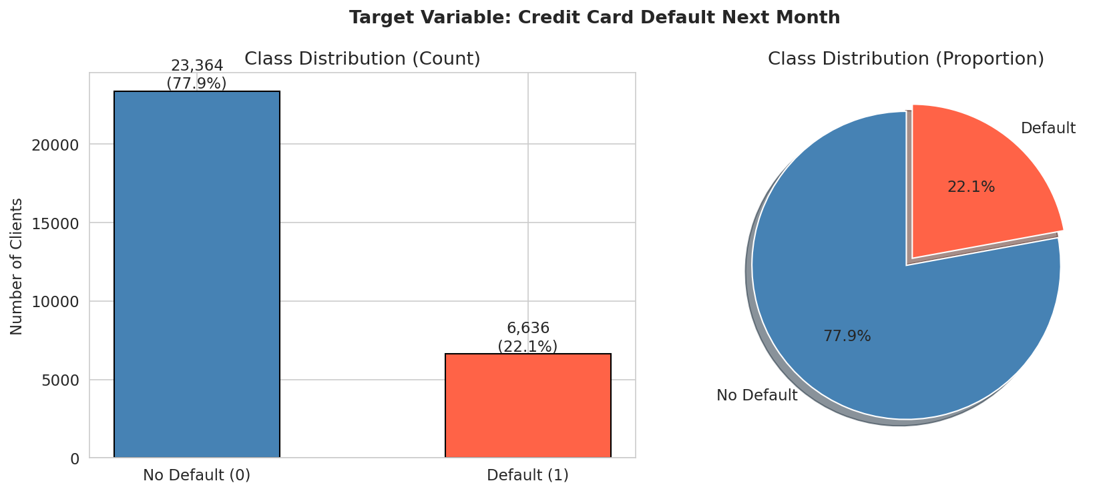
fig_02_demographic_default_rates.png — default rate by sex, education, marriage
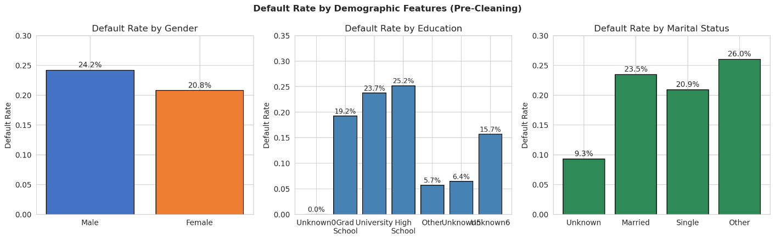

fig_03_age_analysis.png — age distribution and default rate by age group
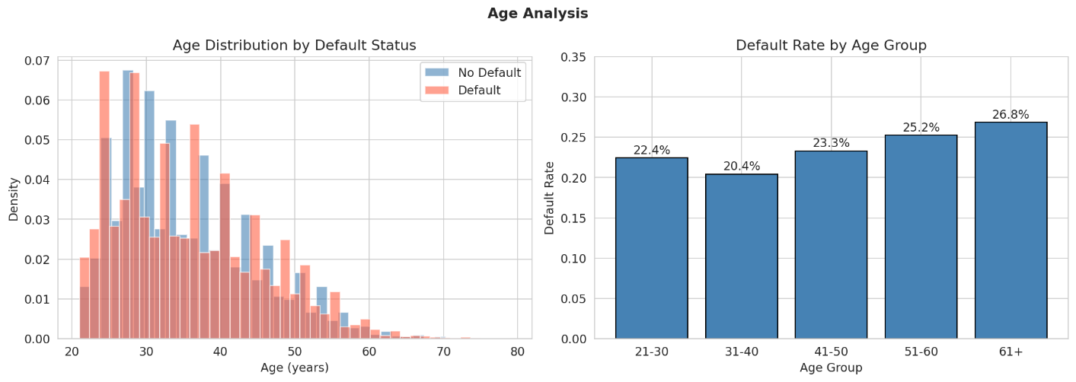

fig_04_payment_history.png — PAY_0–PAY_6 analysis
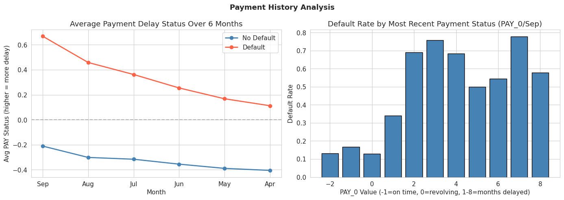

fig_05_correlation_heatmap.png — feature correlations
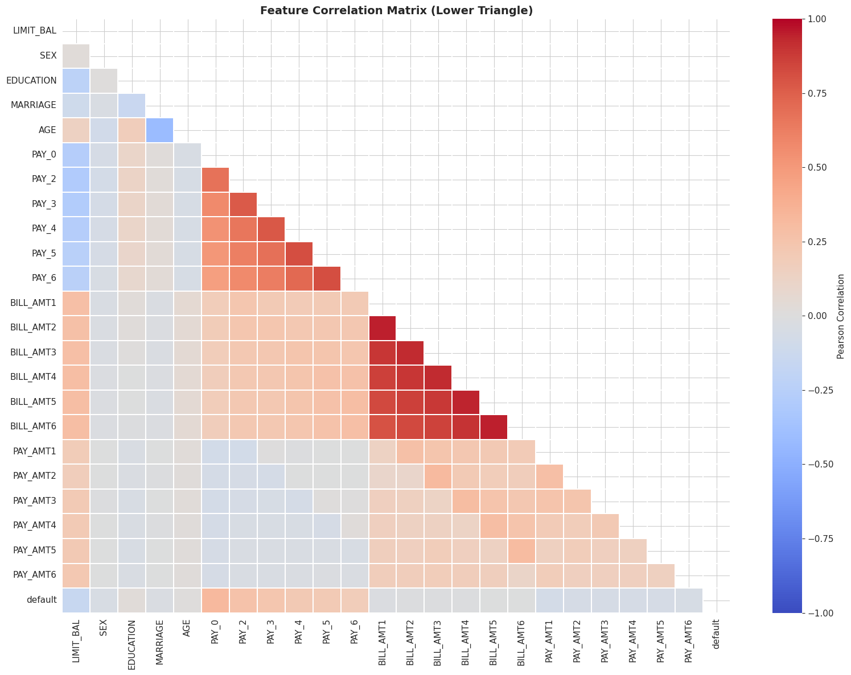

fig_06_pca_variance.png — scree plot + cumulative variance
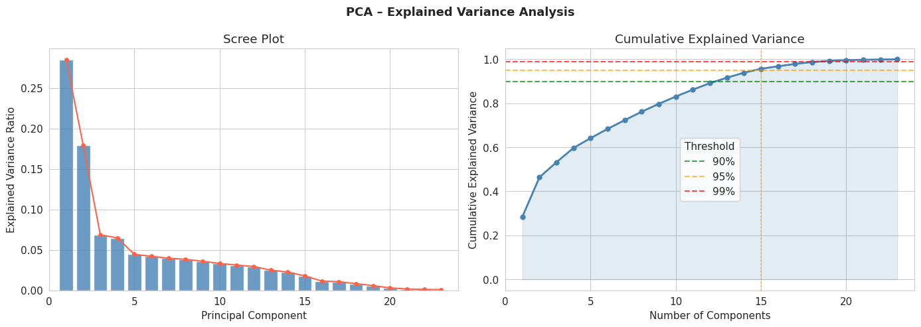

fig_07_pca_2d_scatter.png — 2D PCA class separation
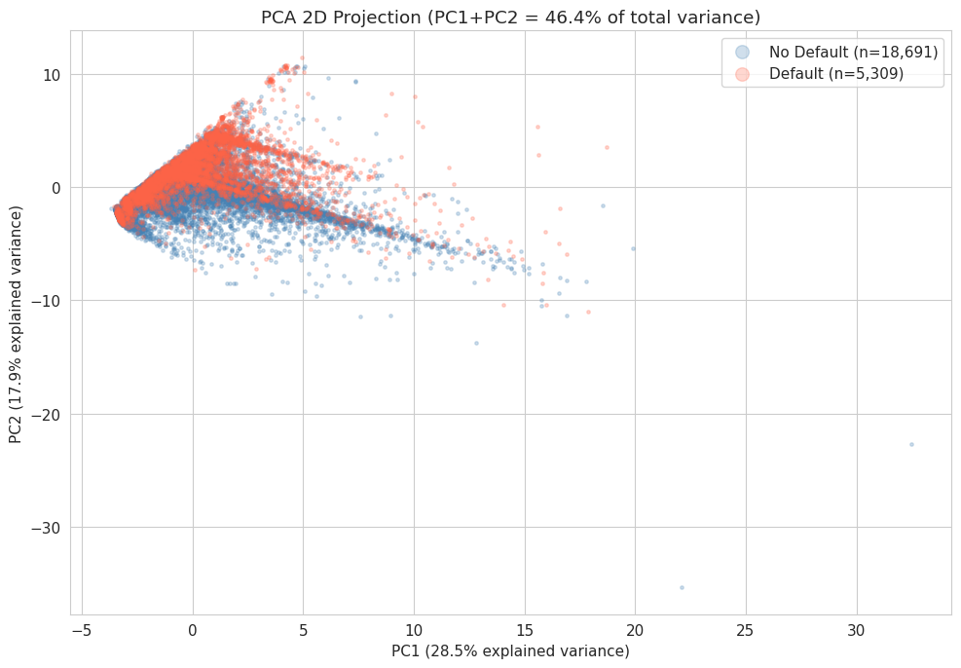

fig_08_model_comparison_roc.png — side-by-side bar chart + ROC curves
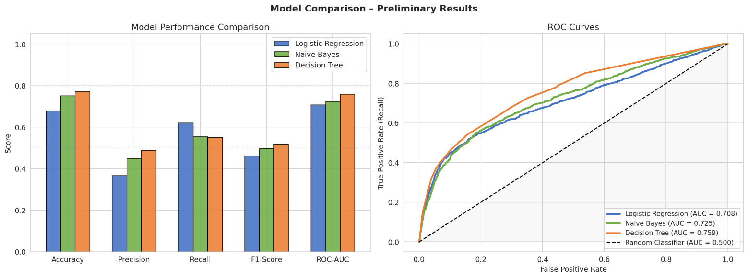

fig_09_feature_importance.png — DT Gini + LR coefficient comparison
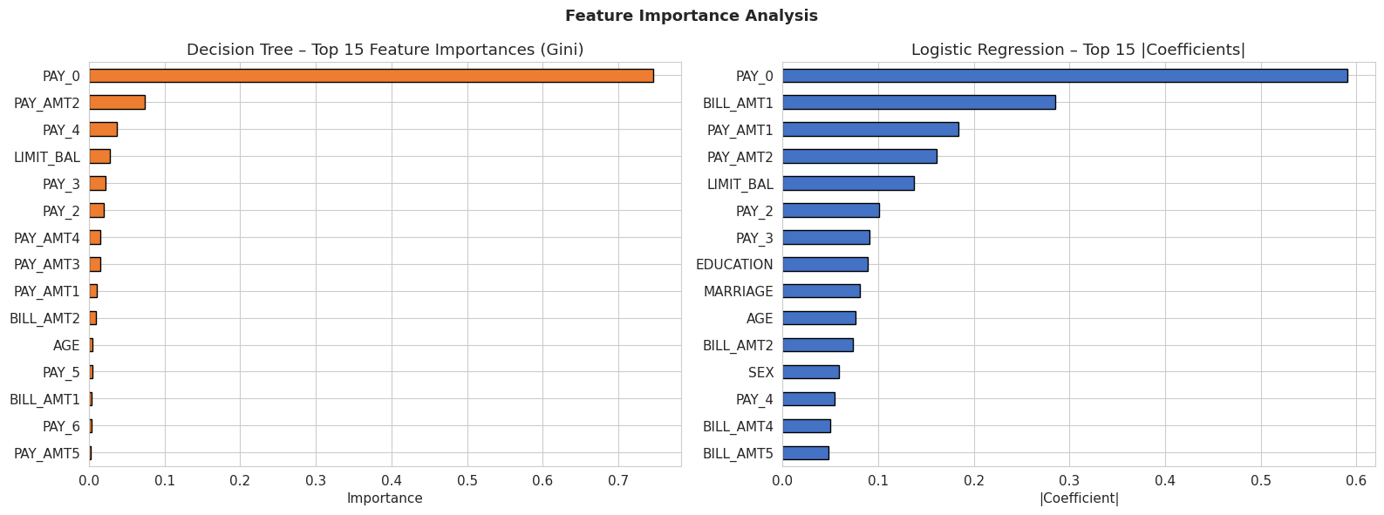

fig_cm_decision_tree – Confusion Matrix
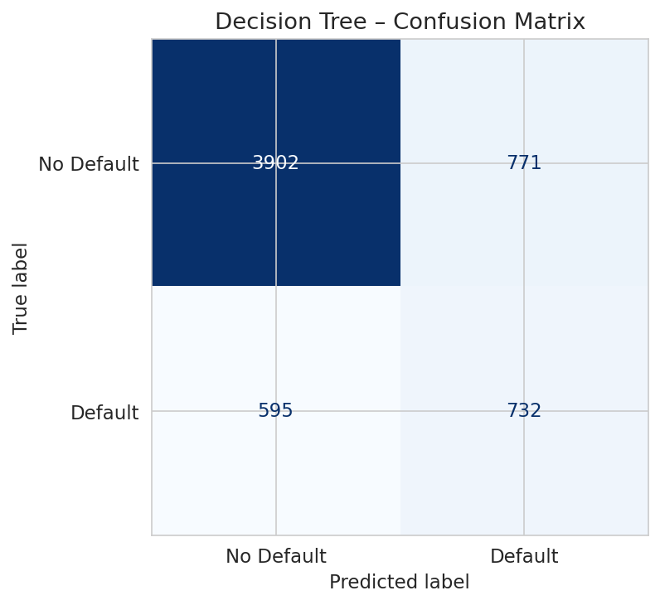

fig_cm_logistic_regression

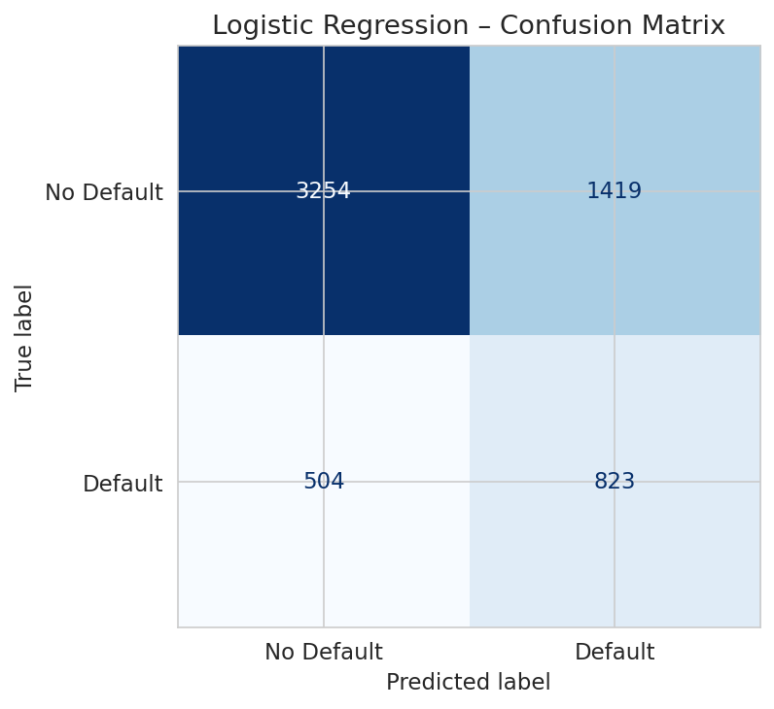

fig_cm_naive_bayes – Confusion Matrix
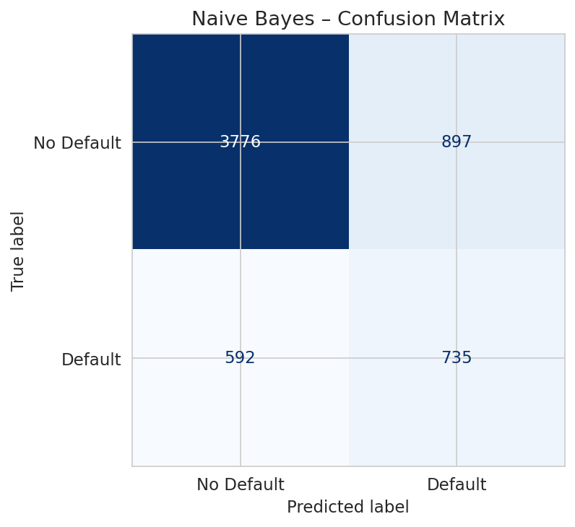

fig_decision_tree_viz.png — tree visualization (top 3 levels)
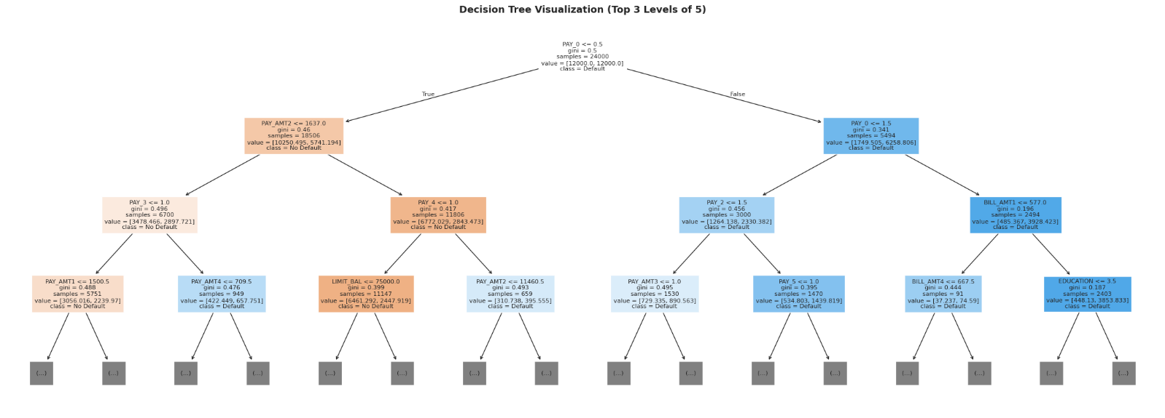

5. Plan for Remainder of the Project & Conclusion

5a. Plan & Timeline

Week Planned Task
Week of Mar 17 ✅ Run notebook; collect outputs and plots
Week of Mar 24 Hyperparameter tuning: GridSearchCV for LR (vary C), DT (vary max_depth, min_samples_leaf)
Week of Mar 31 Address class imbalance with SMOTE (imblearn); re-evaluate all models
Week of Apr 7 Feature engineering: payment utilization ratios (PAY_AMT / BILL_AMT); optionally test Random Forest
Week of Apr 14 Final model selection with complete analysis; write final report; prepare presentation

5b. Team Member Roles

Team Member Contribution to Date Planned Role (Remainder)
1) Spencer Kone:
Setup of the project, implementation of the notebook and management of the GitHub repository Hyperparameter tuning for the final report
2) Muhammad H Bahar:
Ran a notebook on JupyterHub, shared the output of the results Model evaluation, exploring SMOTE

3) Kunapureddy, Leela Pavan Kumar:
Data Cleaning, Feature Engineering, and EDA Implementing Feature Selection, Testing Ensemble Models

4) Maddirala, Shalem Raju:
Documentation, Report Writing, and Final Presentation, Model Deployment and Documentation

5c. Concluding Remarks

In conclusion, our initial exploration of the default credit card client dataset reveals promising results. The Decision Tree model demonstrates superior performance in terms of accuracy, F1-score, and ROC-AUC, suggesting its potential for reliable default prediction. The prominence of PAY_0 as a key predictor and the high degree of feature correlation highlight the need for further investigation and potentially more complex modeling approaches. The class imbalance presents a continued challenge, and future work will focus on addressing this through techniques like SMOTE. While the PCA analysis suggests that linear models may be limited, the Decision Tree’s ability to capture non-linearities offers a robust foundation for further refinement and optimization. This milestone has laid a strong groundwork for the final stage of the project – a comprehensive evaluation of alternative models and a robust strategy for addressing the class imbalance.

6. AI Declaration and Citations

Group 3 Declares:
Tool used: Claude Code (Anthropic) claude.ai, Google Antigravity IDE.

We applied our analysis and critical thinking skills on the data provided to us by using Claude Code. We generated the Python Jupyter notebook code that was resulting from our request to Claude Code for loading the data, the standard scaling and train-test split boilerplate, for training and evaluating the models and finally for creating the visualizations that we required from the matplotlib and seaborn libraries. We also applied some parts of Claude Code to prepare the basic structure of this report.

Evidence: The notebook file CreditDefault_ML_Analysis.ipynb in the GitHub repo was developed with AI coding assistance; the analysis paragraphs in this report were authored by the team

Code Output:
Libraries loaded successfully.
ucimlrepo unavailable (No module named 'ucimlrepo'). Falling back to direct XLS download...
Dataset loaded via direct XLS download.

Dataset shape: (30000, 24)

Column names:
['LIMIT_BAL', 'SEX', 'EDUCATION', 'MARRIAGE', 'AGE', 'PAY_0', 'PAY_2', 'PAY_3', 'PAY_4', 'PAY_5', 'PAY_6', 'BILL_AMT1', 'BILL_AMT2', 'BILL_AMT3', 'BILL_AMT4', 'BILL_AMT5', 'BILL_AMT6', 'PAY_AMT1', 'PAY_AMT2', 'PAY_AMT3', 'PAY_AMT4', 'PAY_AMT5', 'PAY_AMT6', 'default']
=== First 5 Rows ===
 | LIMIT_BAL | SEX | EDUCATION | MARRIAGE | AGE | PAY_0 | PAY_2 | PAY_3 | PAY_4 | PAY_5 | ... | BILL_AMT4 | BILL_AMT5 | BILL_AMT6 | PAY_AMT1 | PAY_AMT2 | PAY_AMT3 | PAY_AMT4 | PAY_AMT5 | PAY_AMT6 | default
ID
1 | 20000 | 2 | 2 | 1 | 24 | 2 | 2 | -1 | -1 | -2 | ... | 0 | 0 | 0 | 0 | 689 | 0 | 0 | 0 | 0 | 1
2 | 120000 | 2 | 2 | 2 | 26 | -1 | 2 | 0 | 0 | 0 | ... | 3272 | 3455 | 3261 | 0 | 1000 | 1000 | 1000 | 0 | 2000 | 1
3 | 90000 | 2 | 2 | 2 | 34 | 0 | 0 | 0 | 0 | 0 | ... | 14331 | 14948 | 15549 | 1518 | 1500 | 1000 | 1000 | 1000 | 5000 | 0
4 | 50000 | 2 | 2 | 1 | 37 | 0 | 0 | 0 | 0 | 0 | ... | 28314 | 28959 | 29547 | 2000 | 2019 | 1200 | 1100 | 1069 | 1000 | 0
5 | 50000 | 1 | 2 | 1 | 57 | -1 | 0 | -1 | 0 | 0 | ... | 20940 | 19146 | 19131 | 2000 | 36681 | 10000 | 9000 | 689 | 679 | 0
5 rows × 24 columns

=== Dataset Info ===
<class 'pandas.core.frame.DataFrame'>
Index: 30000 entries, 1 to 30000
Data columns (total 24 columns):
# Column Non-Null Count Dtype
--- ------ -------------- -----
0 LIMIT_BAL 30000 non-null int64
1 SEX 30000 non-null int64
2 EDUCATION 30000 non-null int64
3 MARRIAGE 30000 non-null int64
4 AGE 30000 non-null int64
5 PAY_0 30000 non-null int64
6 PAY_2 30000 non-null int64
7 PAY_3 30000 non-null int64
8 PAY_4 30000 non-null int64
9 PAY_5 30000 non-null int64
10 PAY_6 30000 non-null int64
11 BILL_AMT1 30000 non-null int64
12 BILL_AMT2 30000 non-null int64
13 BILL_AMT3 30000 non-null int64
14 BILL_AMT4 30000 non-null int64
15 BILL_AMT5 30000 non-null int64
16 BILL_AMT6 30000 non-null int64
17 PAY_AMT1 30000 non-null int64
18 PAY_AMT2 30000 non-null int64
19 PAY_AMT3 30000 non-null int64
20 PAY_AMT4 30000 non-null int64
21 PAY_AMT5 30000 non-null int64
22 PAY_AMT6 30000 non-null int64
23 default 30000 non-null int64
dtypes: int64(24)
memory usage: 5.7 MB

=== Target Variable Distribution ===
default
0 23364
1 6636
Name: count, dtype: int64

Default rate: 22.12%
=== Statistical Summary ===
 | LIMIT_BAL | SEX | EDUCATION | MARRIAGE | AGE | PAY_0 | PAY_2 | PAY_3 | PAY_4 | PAY_5 | ... | BILL_AMT4 | BILL_AMT5 | BILL_AMT6 | PAY_AMT1 | PAY_AMT2 | PAY_AMT3 | PAY_AMT4 | PAY_AMT5 | PAY_AMT6 | default
count | 30000.00 | 30000.00 | 30000.00 | 30000.00 | 30000.00 | 30000.00 | 30000.00 | 30000.00 | 30000.00 | 30000.00 | ... | 30000.00 | 30000.00 | 30000.00 | 30000.00 | 30000.00 | 30000.00 | 30000.00 | 30000.00 | 30000.00 | 30000.00
mean | 167484.32 | 1.60 | 1.85 | 1.55 | 35.49 | -0.02 | -0.13 | -0.17 | -0.22 | -0.27 | ... | 43262.95 | 40311.40 | 38871.76 | 5663.58 | 5921.16 | 5225.68 | 4826.08 | 4799.39 | 5215.50 | 0.22
std | 129747.66 | 0.49 | 0.79 | 0.52 | 9.22 | 1.12 | 1.20 | 1.20 | 1.17 | 1.13 | ... | 64332.86 | 60797.16 | 59554.11 | 16563.28 | 23040.87 | 17606.96 | 15666.16 | 15278.31 | 17777.47 | 0.42
min | 10000.00 | 1.00 | 0.00 | 0.00 | 21.00 | -2.00 | -2.00 | -2.00 | -2.00 | -2.00 | ... | -170000.00 | -81334.00 | -339603.00 | 0.00 | 0.00 | 0.00 | 0.00 | 0.00 | 0.00 | 0.00
25% | 50000.00 | 1.00 | 1.00 | 1.00 | 28.00 | -1.00 | -1.00 | -1.00 | -1.00 | -1.00 | ... | 2326.75 | 1763.00 | 1256.00 | 1000.00 | 833.00 | 390.00 | 296.00 | 252.50 | 117.75 | 0.00
50% | 140000.00 | 2.00 | 2.00 | 2.00 | 34.00 | 0.00 | 0.00 | 0.00 | 0.00 | 0.00 | ... | 19052.00 | 18104.50 | 17071.00 | 2100.00 | 2009.00 | 1800.00 | 1500.00 | 1500.00 | 1500.00 | 0.00
75% | 240000.00 | 2.00 | 2.00 | 2.00 | 41.00 | 0.00 | 0.00 | 0.00 | 0.00 | 0.00 | ... | 54506.00 | 50190.50 | 49198.25 | 5006.00 | 5000.00 | 4505.00 | 4013.25 | 4031.50 | 4000.00 | 0.00
max | 1000000.00 | 2.00 | 6.00 | 3.00 | 79.00 | 8.00 | 8.00 | 8.00 | 8.00 | 8.00 | ... | 891586.00 | 927171.00 | 961664.00 | 873552.00 | 1684259.00 | 896040.00 | 621000.00 | 426529.00 | 528666.00 | 1.00
8 rows × 24 columns
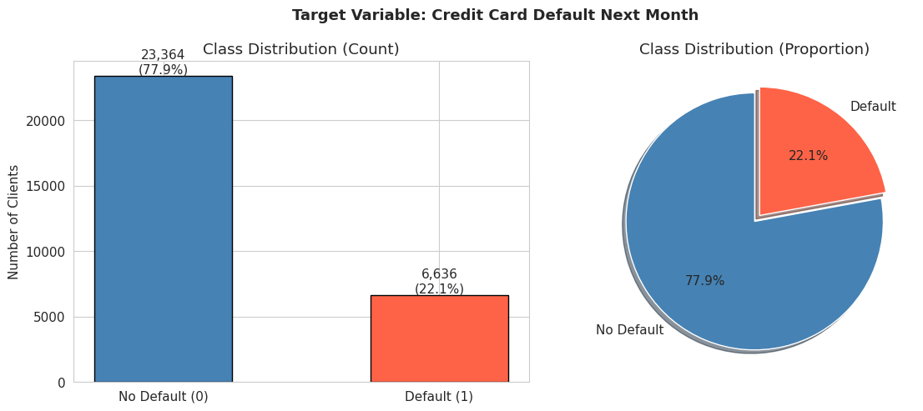
Class imbalance ratio: 3.5:1 (no default : default)
Note: Dataset is moderately imbalanced. class_weight="balanced" will be used in models.
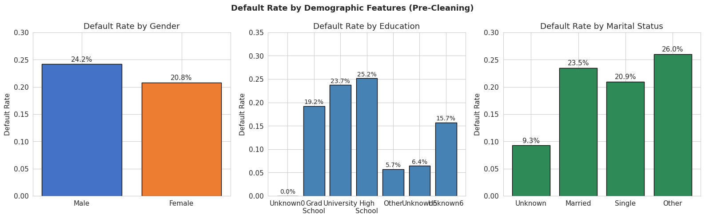
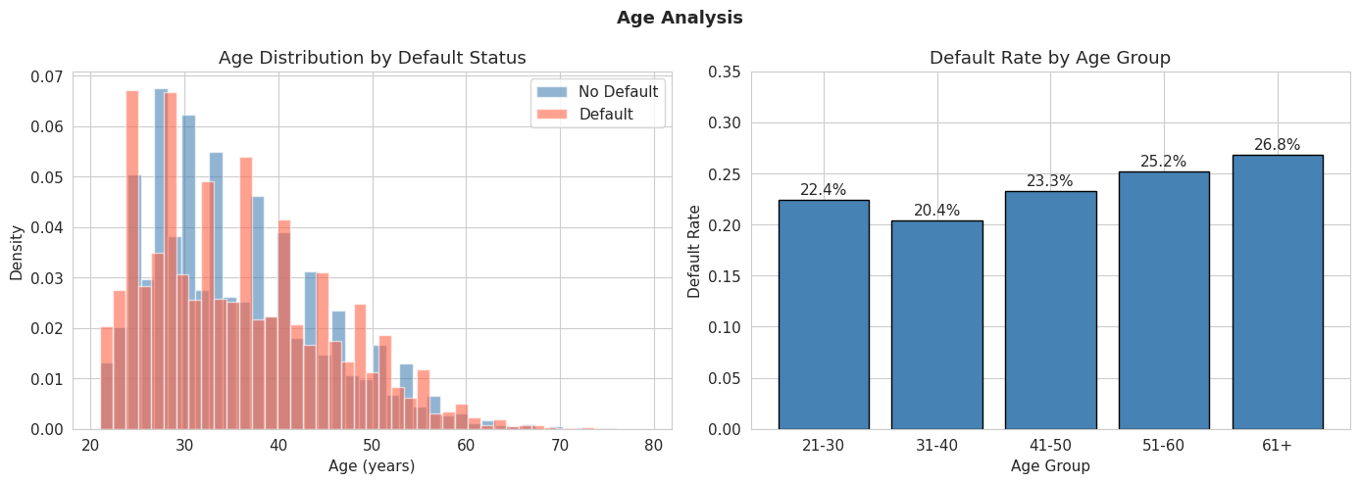

=== Top 10 Features Correlated with Default ===
|Correlation|
PAY_0 0.3248
PAY_2 0.2636
PAY_3 0.2353
PAY_4 0.2166
PAY_5 0.2041
PAY_6 0.1869
LIMIT_BAL 0.1535
PAY_AMT1 0.0729
PAY_AMT2 0.0586
PAY_AMT4 0.0568
=== Missing Values ===
Total missing: 0
No missing values found. Dataset is complete.

Duplicate rows: 35

EDUCATION values (before): [np.int64(0), np.int64(1), np.int64(2), np.int64(3), np.int64(4), np.int64(5), np.int64(6)]
Undocumented counts: 345 rows
EDUCATION values (after): [np.int64(1), np.int64(2), np.int64(3), np.int64(4)]

MARRIAGE values (before): [np.int64(0), np.int64(1), np.int64(2), np.int64(3)]
Undocumented counts: 54 rows
MARRIAGE values (after): [np.int64(1), np.int64(2), np.int64(3)]

Cleaning complete.
Feature matrix shape: (30000, 23)
Target vector shape: (30000,)

Features (23):
1. LIMIT_BAL
2. SEX
3. EDUCATION
4. MARRIAGE
5. AGE
6. PAY_0
7. PAY_2
8. PAY_3
9. PAY_4
10. PAY_5
11. PAY_6
12. BILL_AMT1
13. BILL_AMT2
14. BILL_AMT3
15. BILL_AMT4
16. BILL_AMT5
17. BILL_AMT6
18. PAY_AMT1
19. PAY_AMT2
20. PAY_AMT3
21. PAY_AMT4
22. PAY_AMT5
23. PAY_AMT6
Train size: 24,000 samples (80%)
Test size: 6,000 samples (20%)

Train default rate: 22.12%
Test default rate: 22.12%
Stratified split confirmed: rates match.

StandardScaler fit on train set.
Train mean post-scale: 0.000000 (expected ~0)
Train std post-scale: 1.000000 (expected ~1)
=== PCA Variance Summary ===
Total features: 23
Components for 90% variance: 13
Components for 95% variance: 15
Components for 99% variance: 19

Top 5 components explain: 64.17% of variance
Top 10 components explain: 83.09% of variance

Observation: The two classes overlap significantly in the first two PCs,
suggesting linear separability is limited - non-linear models may perform better.
evaluate_model() helper defined.

=======================================================
MODEL: Logistic Regression
=======================================================
precision recall f1-score support

No Default 0.87 0.70 0.77 4673
Default 0.37 0.62 0.46 1327

accuracy 0.68 6000
macro avg 0.62 0.66 0.62 6000
weighted avg 0.76 0.68 0.70 6000

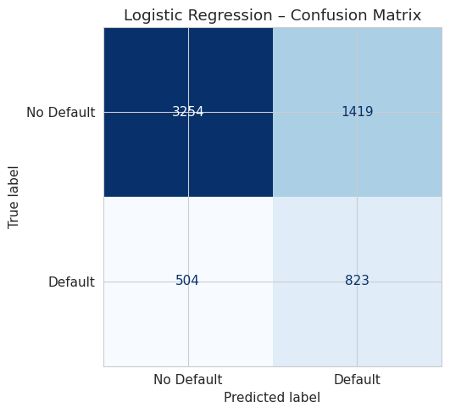
5-Fold CV ROC-AUC: 0.7264 ± 0.0106

=======================================================
MODEL: Naive Bayes
=======================================================
precision recall f1-score support

No Default 0.86 0.81 0.84 4673
Default 0.45 0.55 0.50 1327

accuracy 0.75 6000
macro avg 0.66 0.68 0.67 6000
weighted avg 0.77 0.75 0.76 6000

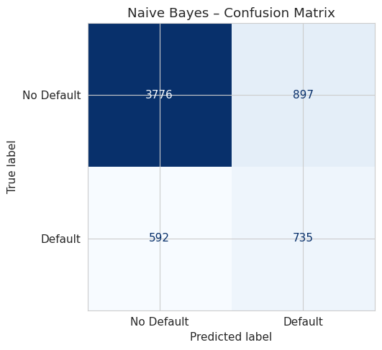
5-Fold CV ROC-AUC: 0.7365 ± 0.0102

=======================================================
MODEL: Decision Tree
=======================================================
precision recall f1-score support

No Default 0.87 0.84 0.85 4673
Default 0.49 0.55 0.52 1327

accuracy 0.77 6000
macro avg 0.68 0.69 0.68 6000
weighted avg 0.78 0.77 0.78 6000

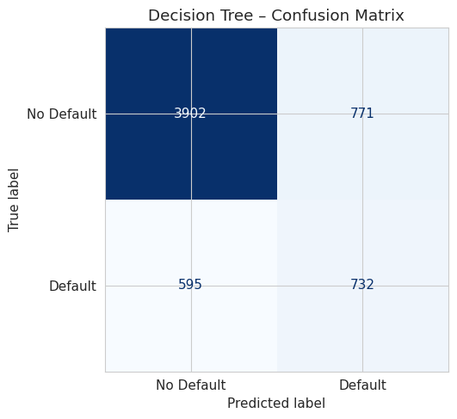
5-Fold CV ROC-AUC: 0.7577 ± 0.0067

=== Model Performance Comparison ===
 | Accuracy | Precision | Recall | F1-Score | ROC-AUC | CV_AUC_Mean | CV_AUC_Std
Model
Logistic Regression | 0.6795 | 0.3671 | 0.6202 | 0.4612 | 0.7084 | 0.7264 | 0.0106
Naive Bayes | 0.7518 | 0.4504 | 0.5539 | 0.4968 | 0.7248 | 0.7365 | 0.0102
Decision Tree | 0.7723 | 0.4870 | 0.5516 | 0.5173 | 0.7589 | 0.7577 | 0.0067

Best F1-Score : Decision Tree (0.5173)
Best ROC-AUC : Decision Tree (0.7589)

=== Top 10 Features: Decision Tree (Gini Importance) ===
PAY_0 0.7461
PAY_AMT2 0.0737
PAY_4 0.0372
LIMIT_BAL 0.0276
PAY_3 0.0225
PAY_2 0.0200
PAY_AMT4 0.0150
PAY_AMT3 0.0148
PAY_AMT1 0.0105
BILL_AMT2 0.0089

=== Top 10 Features: Logistic Regression (|Coefficient|) ===
PAY_0 0.5903
BILL_AMT1 0.2853
PAY_AMT1 0.1843
PAY_AMT2 0.1612
LIMIT_BAL 0.1369
PAY_2 0.1010
PAY_3 0.0909
EDUCATION 0.0887
MARRIAGE 0.0809
AGE 0.0761
=================================================================
MILESTONE 2 – PRELIMINARY RESULTS SUMMARY
=================================================================
 | Accuracy | Recall | F1-Score | ROC-AUC
Model
Logistic Regression | 0.6795 | 0.6202 | 0.4612 | 0.7084
Naive Bayes | 0.7518 | 0.5539 | 0.4968 | 0.7248
Decision Tree | 0.7723 | 0.5516 | 0.5173 | 0.7589

Key Observations:
1. PAY_0 (most recent payment status) is the strongest predictor
2. Payment history features (PAY_0 - PAY_6) dominate feature importance
3. PCA shows significant class overlap in first 2 components
4. Class imbalance (78/22) requires balanced weighting or resampling

Next Steps (for final report):
1. Hyperparameter tuning via GridSearchCV
2. Address class imbalance with SMOTE (imblearn)
3. Consider ensemble models (Random Forest, Gradient Boosting)
4. Feature engineering: payment utilization ratios (PAY_AMT/BILL_AMT)
5. Final model selection with comprehensive analysis

Citations

Harris, C. R., et al. (2020). Array programming with NumPy. Nature, 585, 357–362. https://doi.org/10.1038/s41586-020-2649-2

Hunter, J. D. (2007). Matplotlib: A 2D graphics environment. Computing in Science & Engineering, 9(3), 90–95. https://doi.org/10.1109/MCSE.2007.55

UCI Machine Learning Repository. (2016). Default of Credit Card Clients (Dataset ID 350). https://archive.ics.uci.edu/dataset/350/default+of+credit+card+clients

Pandas Development Team. (2024). pandas: powerful Python data analysis toolkit (v2.x). https://pandas.pydata.org

Pedregosa, F., Varoquaux, G., Gramfort, A., Michel, V., Thirion, B., Grisel, O., ... & Duchesnay, E. (2011). Scikit-learn: Machine Learning in Python. Journal of Machine Learning Research, 12, 2825–2830. https://scikit-learn.org

Waskom, M. L. (2021). seaborn: statistical data visualization. Journal of Open Source Software, 6(60), 3021. https://doi.org/10.21105/joss.03021

Yeh, I. C., & Lien, C. H. (2009). The comparisons of data mining techniques for the predictive accuracy of probability of default of credit card clients. Expert Systems with Applications, 36(2), 2473–2480. https://doi.org/10.1016/j.eswa.2007.12.020

